DATA MINING: FINAL PROJECT
Wine quality prediction using Radom Forest, KNN and LSTM

- Goal: is to compare the performance of three classification algorithms (Random Forest, KNN, and LSTM) on the red wine dataset using 10-fold cross-validation. Metrics like TP, TN, FP, FN, TSS, HSS, and others are manually calculated for each fold and averaged. Based on the outcomes the best performing model is discussed.
- Code and Outcomes:

Imports and installation:

Requirements.txt consists of all of the following:
Ensure to use

Pip install -r requirements.txt

pandas==1.5.3
numpy==1.26.4
matplotlib==3.8.2
seaborn==0.12.2
plotly==5.15.0
scikit-learn==1.3.1
tensorflow==2.17.1
termcolor==2.5.0
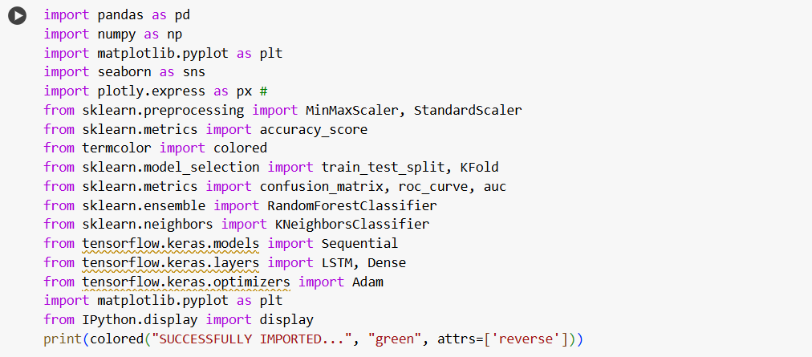al
Data Collection:
Next Read the CSV file. Here I am using red wine quality dataset.
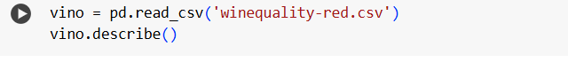

Description of the dataset and information of the same

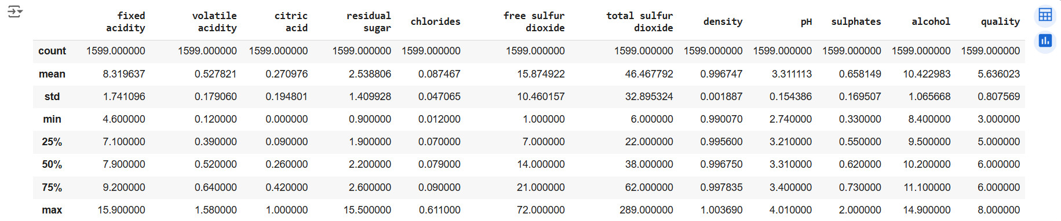

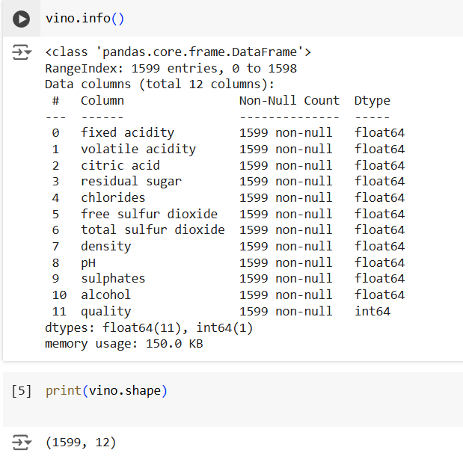
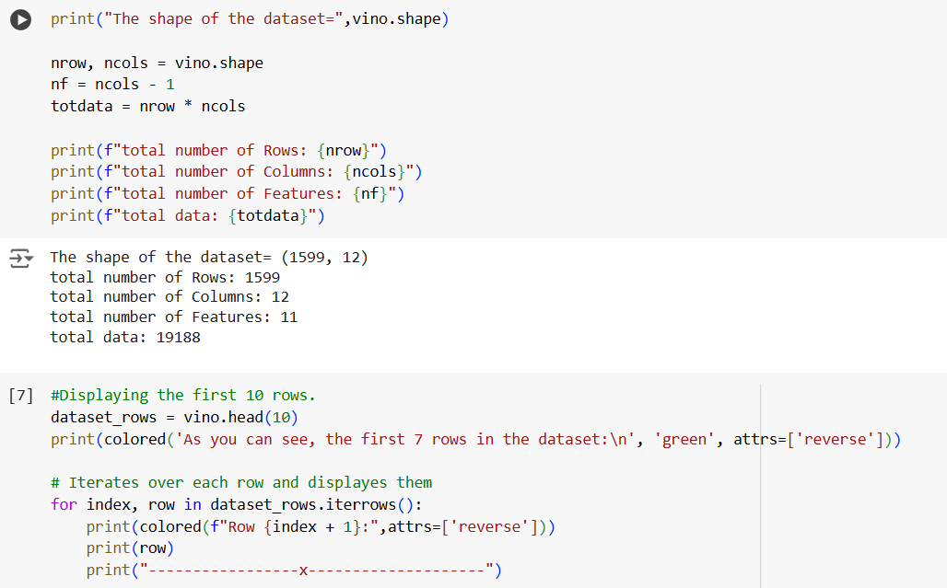
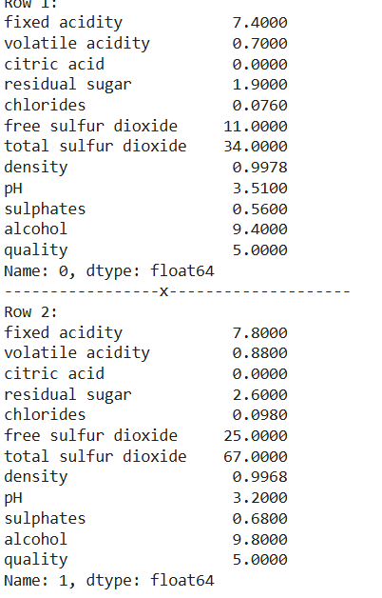

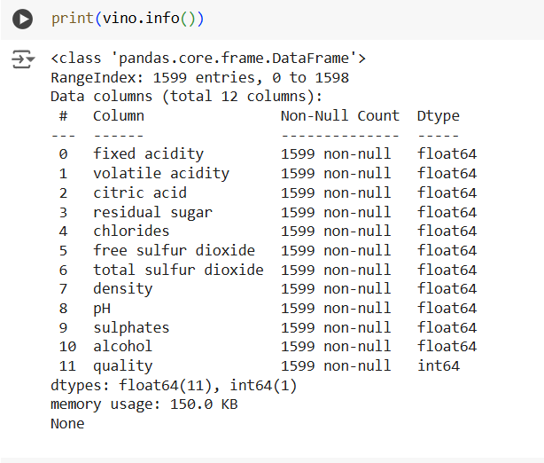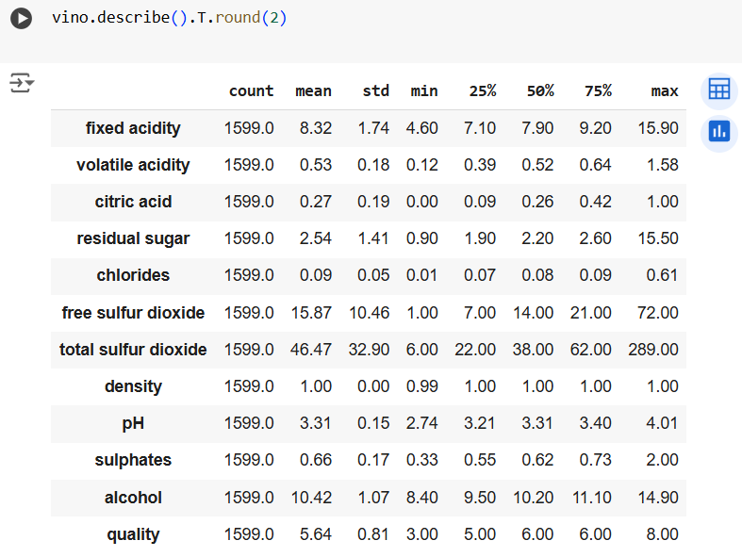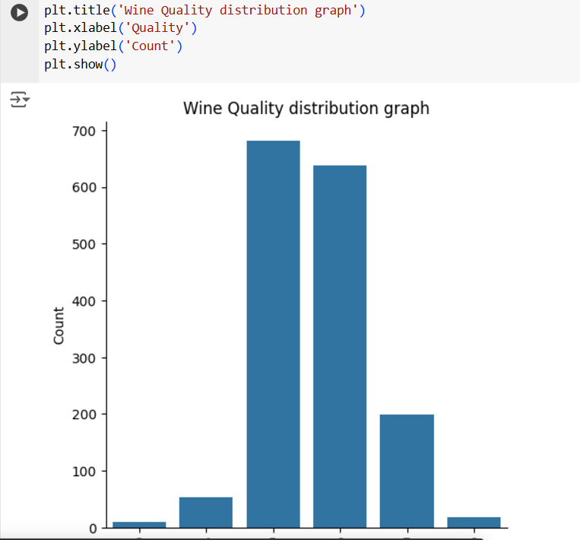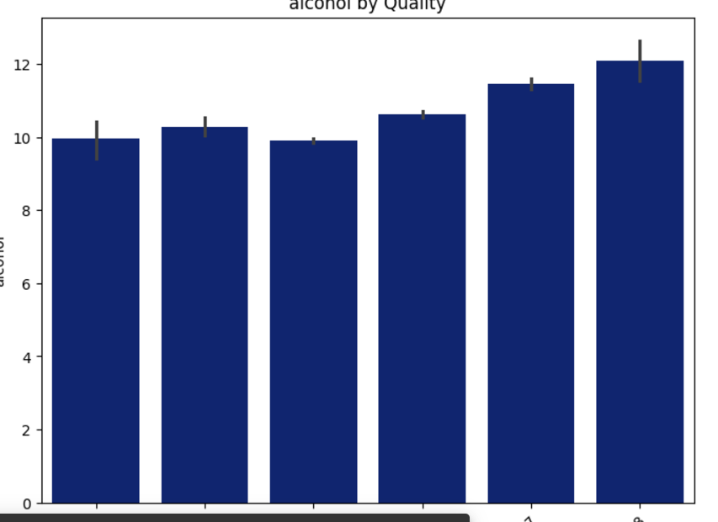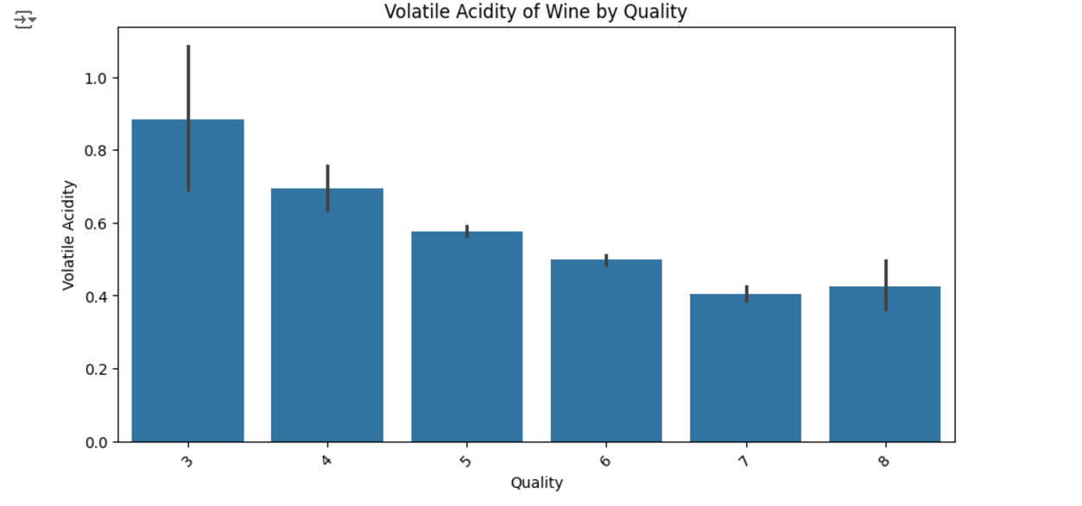
Data Preparation: : This includes cleaning the data to remove inconsistencies, mistakes, and outliers.

Calculate total number of nulls present 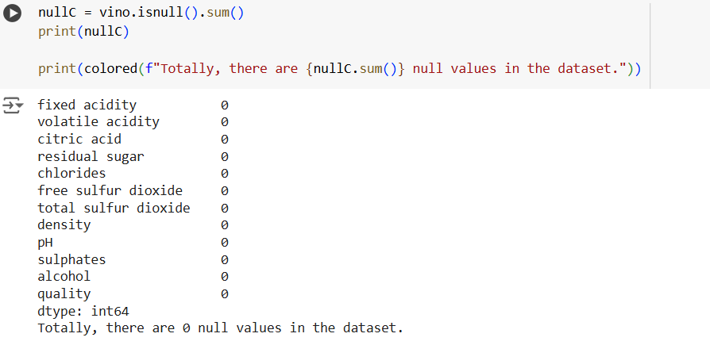
Display all the outliers
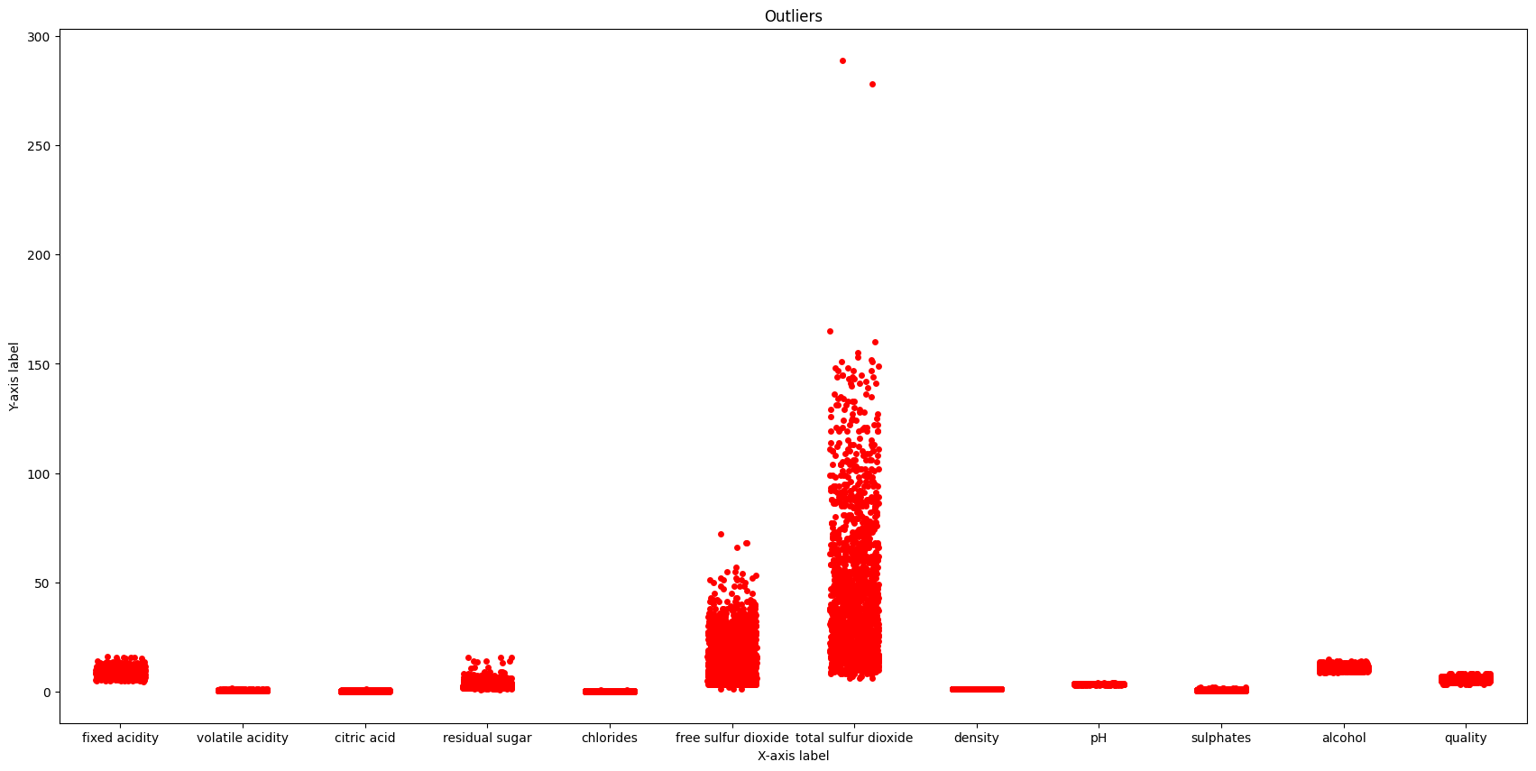
Removing Outliers:
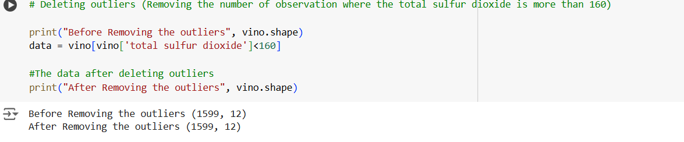
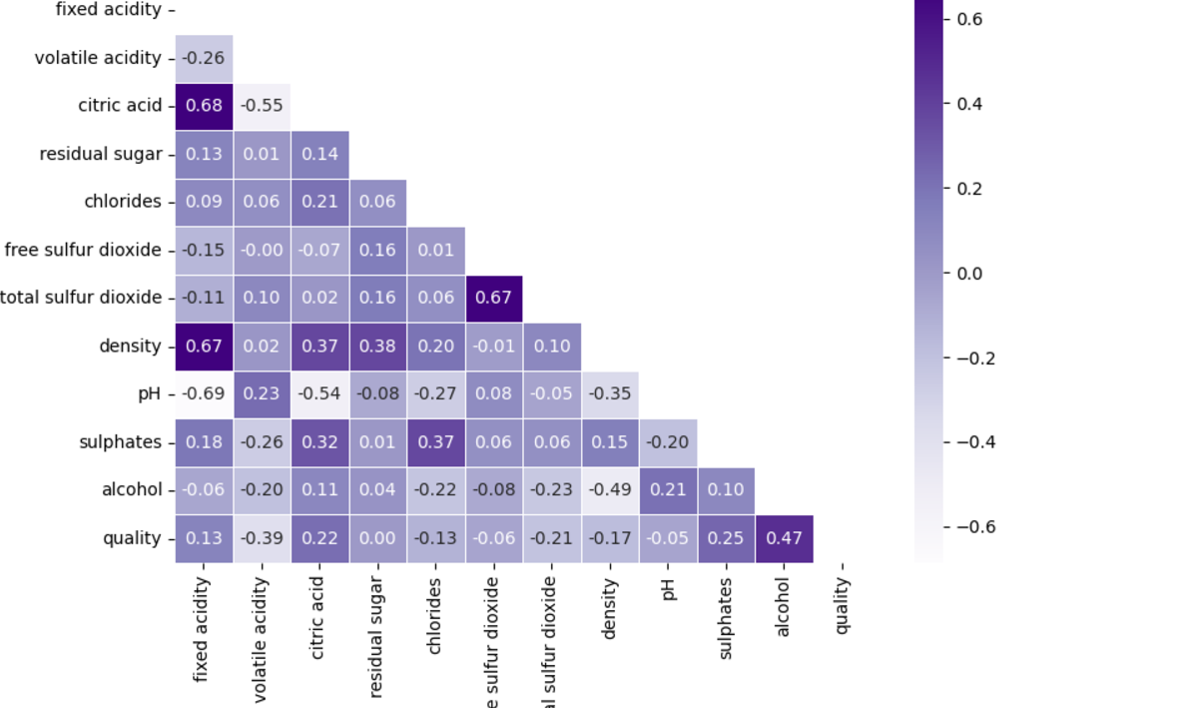
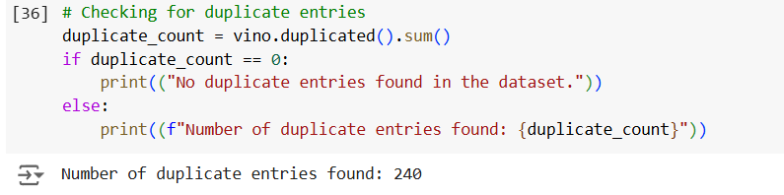
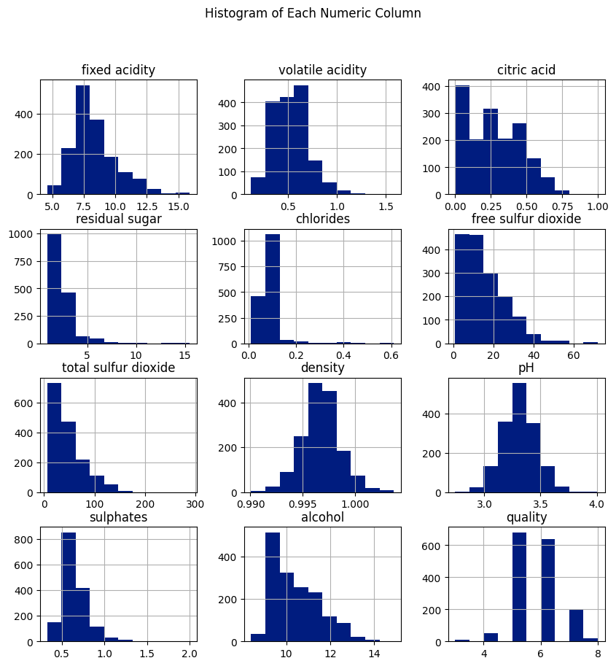
Relationship pair:
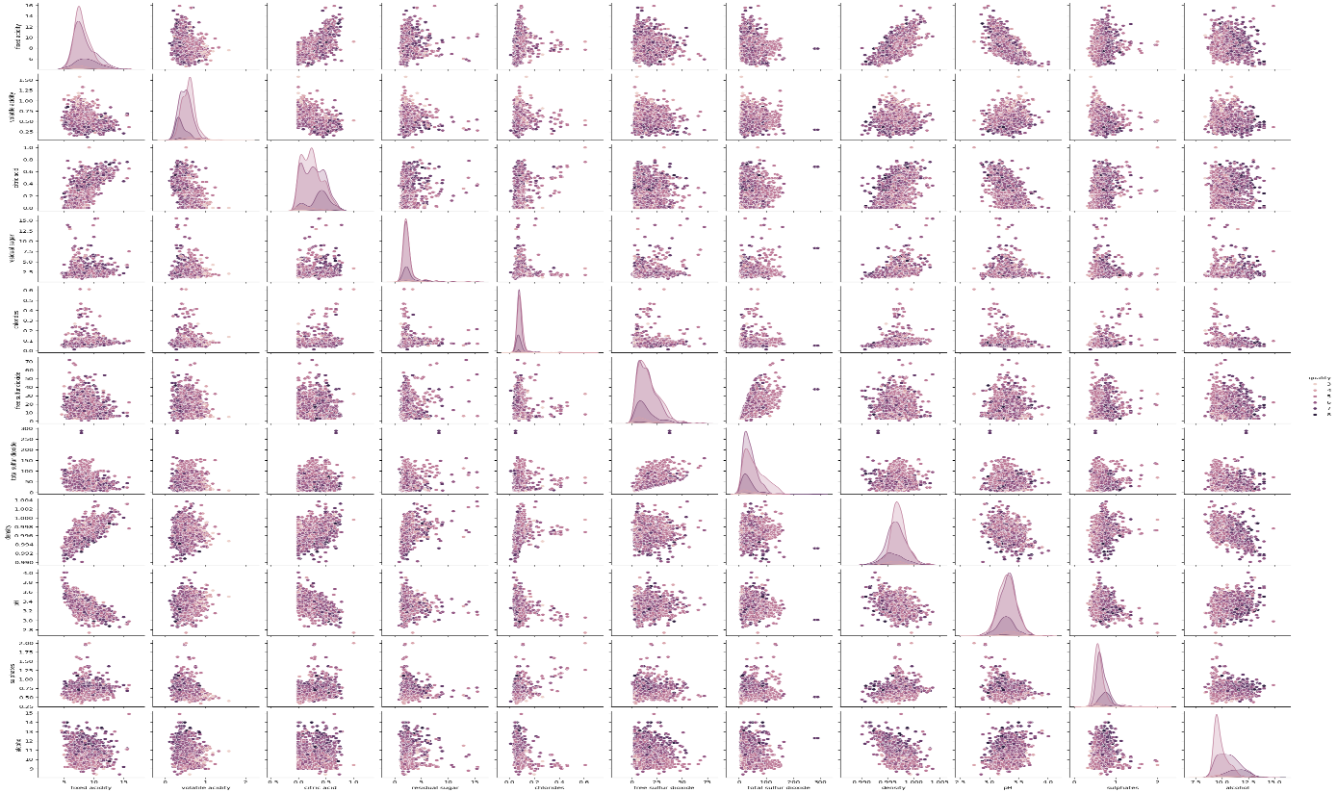

Quality Count:
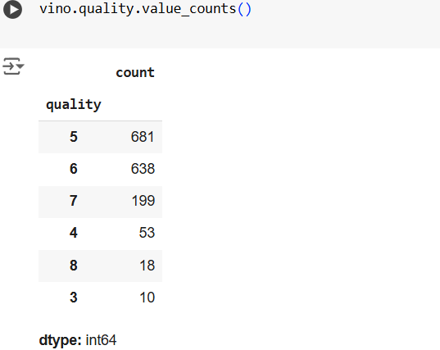
Model selection: This involves choosing a model. Here we have considered Radom Forest, LSTM and KNN models for evaluation.
Radom Forest: Random forest is an algorithm that generates a 'forest' of decision trees. It then takes these many decision trees and combines them to avoid overfitting and produce more accurate predictions.
KNN: KNN finds the most similar data points to a new data point, and then uses the majority of those points' classes or values to predict the new data point's class or value.
LSTM: LSTMs Long Short-Term Memory is a type of RNNs Recurrent Neural Network that can detain long-term dependencies in sequential data. LSTMs are able to process and analyze sequential data, such as time series, text, and speech.
Model training: This involves feeding the model the data so it can teach itself.
Model evaluation: This involves testing the model's performance on a different training set before using it on actual data.
Parameter tuning: This involves testing the original model parameters and increasing training to improve results.
Prediction: This involves using the model to answer questions and make predictions on new data.

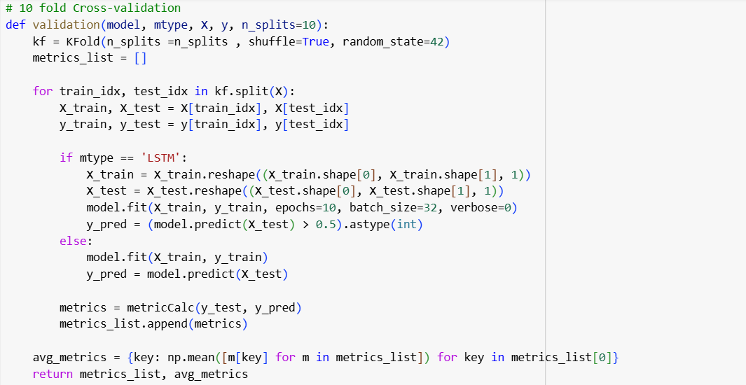
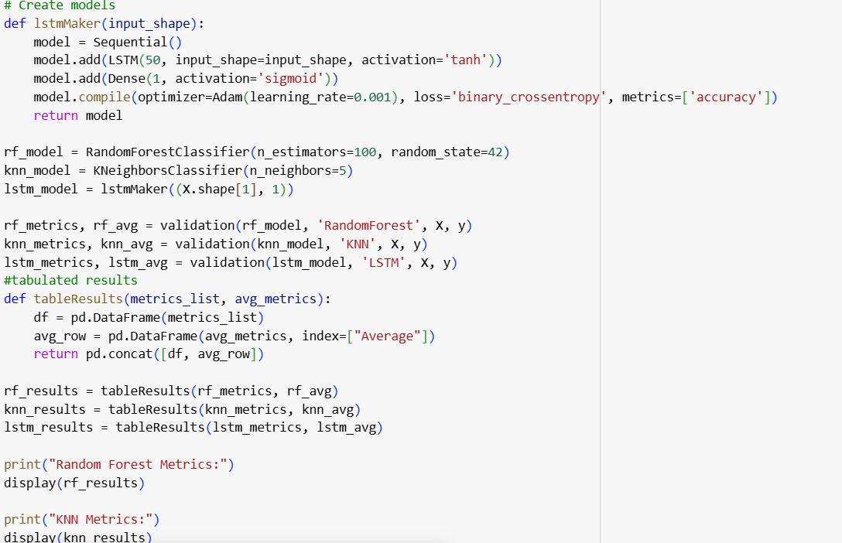
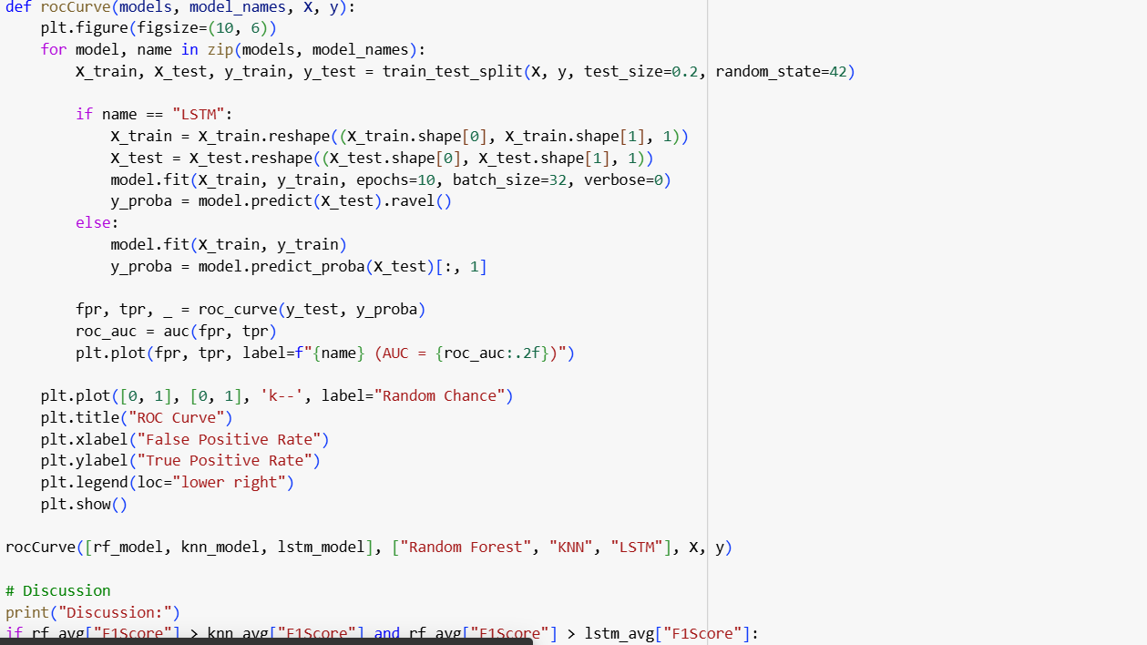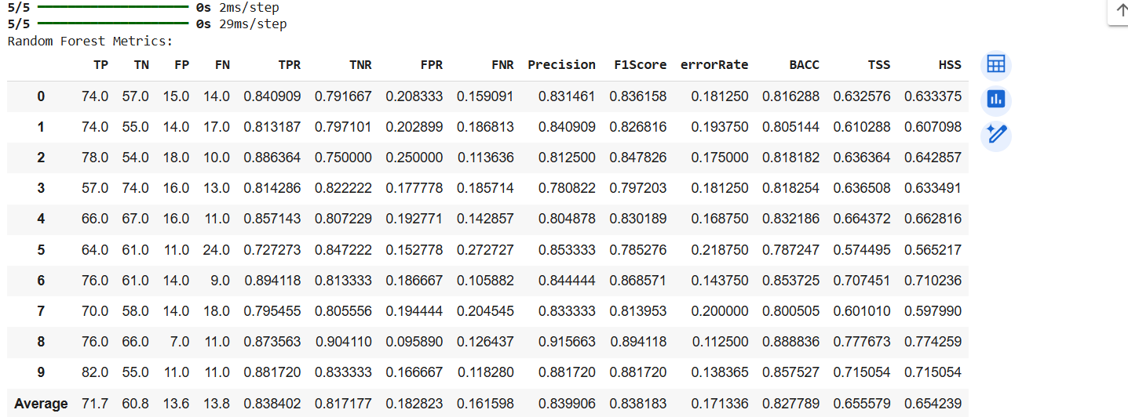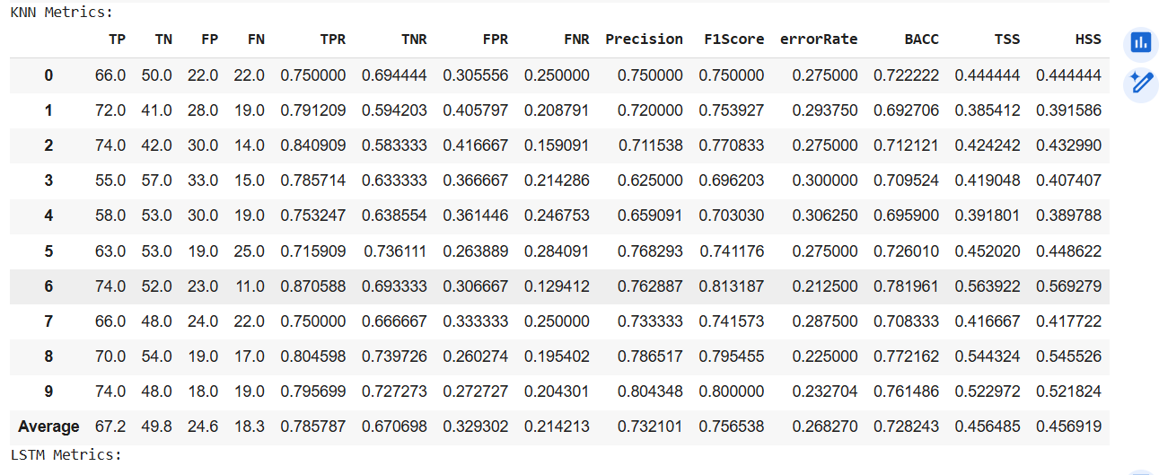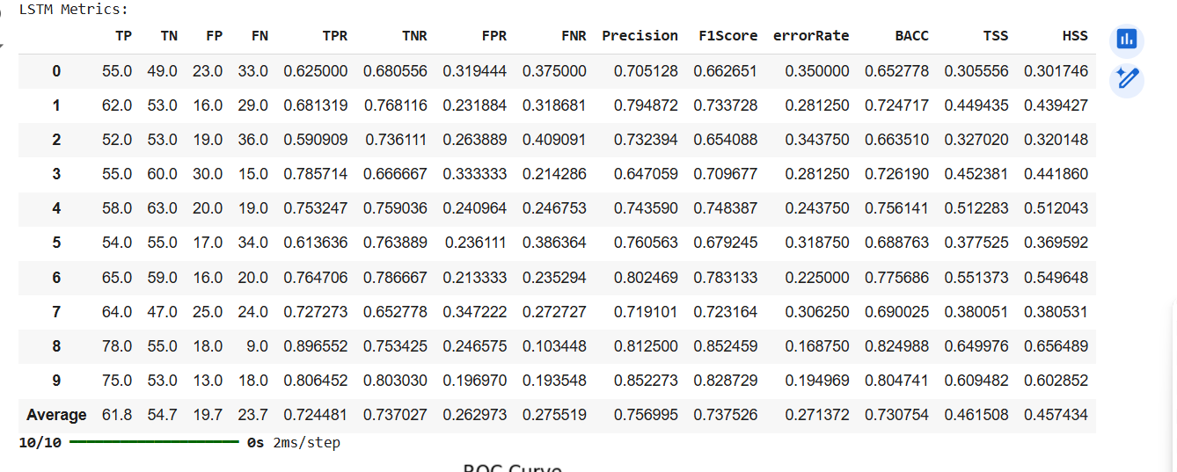

- Conclusion:
After comparing the Random Forest, KNN, and LSTM classifiers using 10-fold cross-validation, we can draw the following insights:
Algorithm Performance:
  - Random Forest emerged as the most reliable model, consistently delivering the highest F1-score and balanced accuracy. Its ability to combine multiple decision trees helps it handle complex patterns and reduce overfitting.
  - KNN performed well in certain cases where data clusters or local relationships were significant. However, it was less effective with high-dimensional data and sensitive to noisy features.
  - LSTM, while typically strong for sequential or time-series data, showed mixed results on this dataset, likely because the data lacks temporal relationships. Additionally, it required more computational resources.
ROC Curve Insights:
  - The Random Forest had the highest Area Under the Curve (AUC), indicating strong performance in distinguishing between the classes.
  - Both KNN and LSTM also demonstrated decent AUC values but were less consistent across data splits.
Final Recommendation:
For this dataset, Random Forest is the most suitable choice due to its balance of accuracy, efficiency, and ability to handle diverse data characteristics. This analysis highlights that choosing the right model depends not only on raw performance metrics but also on the specific needs of the problem, dataset properties, and computational constraints.

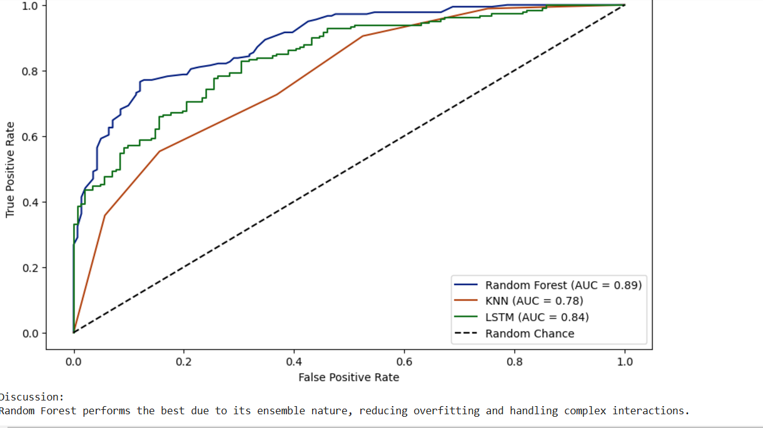
The above dataset was taken from Kaggle:
https://www.kaggle.com/datasets/lovishbansal123/red-wine-quality
Do the following to get the dataset directly from Kaggle:
import kagglehub
# Download latest version
path = kagglehub.dataset_download("lovishbansal123/red-wine-quality")
print("Path to dataset files:", path)

Personal Github Link: https://github.com/ana-bharadwaj/DataMiningFinal.git
Find detailed Readme.md in github to run.

